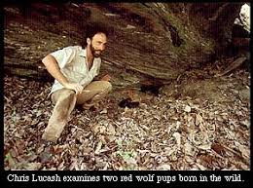
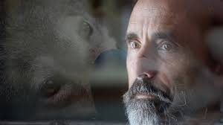
Christopher Lucash lived deeply with a full energy, with an adventurous spirit. He loved vastly, gave all, and dedicated his life to the care and repair of this broken world. He chose the work of red wolf/endangered species restoration...or perhaps that work chose him. He spent years in the company of wolves, coyotes, bobcats and bears with a determined heart to end suffering.
When Chris wasn't tracking or trapping wolves - exposed to the vast, ALS-causing, pesticide sprayed, industrial agricultural fields of eastern NC - he was at home with his family building a homestead. Chris loved his wife and children with a calm, yet fierce dedication. While he died earlier than we all expect to, he showed us how deeply one could live, taught us much in the way of skills and crafts, and encouraged the know-how he had learned. And in the end, when no amount of bargaining would work, he gifted those of us who were blessed with nearness, a profound learning: how to die. He taught us to the end of his days, to the very last moment. And we are grateful.
Chris died peacefully in his sleep on June 4, 2016, one year and two days after his diagnosis. He was surrounded by love at his death, arms encircled, in his own bed at home in Moncure, NC, where he knew the abundant support and care of a community who surrounded him with song and blessing during his dying time.

