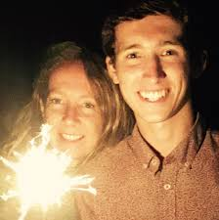
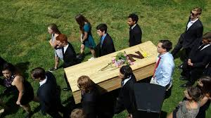
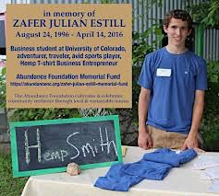
Zafer Julian Estill was born and raised in the woods of Chatham County where the Sanctuary of the Burrow is located. He was the first member of the burial ground. Zafer left this world on April 14, 2016. He died in Boulder Colorado at age 19 after smoking heroin and was flown home to be buried. Zafer was a beautiful ambitious rebel. He founded a hemp clothing company in high school because he thought hemp was the future. Zafer was on the wrestling team and was number one on the tennis team at Northwood High School in Pittsboro. Zafer loved travel, music, cooking, composting and fast food. Most of all Zafer loved his family. Z went to Mardi Gras and secretly got a tattoo on his back of the flatirons of Boulder. We honoured Zafer by building the flatirons as his headstone of his grave.

